TORONTO HAKKA CONFERENCE
Preliminary Program

FRIDAY JUNE 29, CHINESE CULTURAL CENTRE (5183 Sheppard Ave. E)
7 - 9 pm RECEPTION for speakers, guests, Yongding County officials, registrants

SATURDAY JUNE 30, YORK UNIVERSITY - KEELE CAMPUS, VARI HALL
8 - 9 am REGISTRATION: Rotunda, Vari Hall
9 - 9:30 am OPENING CEREMONY (Senator Vivienne Poy)
9:30 - 10:15 KEYNOTE ADDRESS - LEGACY AND CONTINUITY
Shiu Loon Kong, C.M., Ph.D.
Professor Emeritus, University of Toronto
10:15-10:30 Tea Break
10:30-11:45 HISTORY CHANNEL DOCUMENTARY ON HAKKA TULOU
Introduced by Jorg Ostrowski
Commentary by Yongding County officials & Hakka Tulou Alliance

11:45-1:15 LUNCH (displays, booths, performances in Rotunda) (youth group photo)

1:15- 2:30 CONCURRENT SESSIONS (A)
HAKKA IN CHINA - - Leader, Li Xiaoyan & Yongding County officials
HAKKA IN MALAYSIA - Leader, Dr. Thin Miew Choo
HAKKA IN INDIA - Leader, Kwai-yun Li
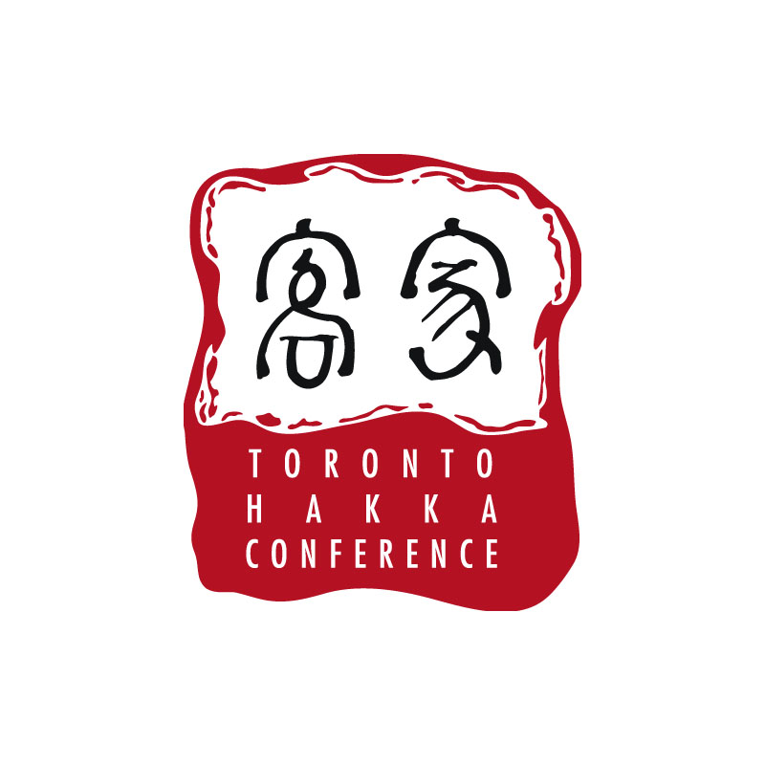
HAKKA IN MAURITIUS - Leader, Dr. Joyce Leung
HAKKA IN THE CARIBBEAN - Leader, Prof. Anne-Marie Lee-Loy

2:30 - 3:00 Tea Break and group photo of all attendees & speakers

3:00 - 4:00 HAKKA POP MUSIC, EAST AND WEST - Nam Low
This presentation outlines the prospects for Hakka pop music in Mainland China, Taiwan, South East Asia, and hopefully Canada. Electronic media allows lyrics to be composed in one country and set to music in another and vice versa. The presenter was co-organizer of a cross-straits pop music festival held in Meizhou, the world capital of the Hakka nation.
Reserved seating for teens and young adults

CONCURRENT SESSIONS (B)
HAKKA HEROES IN THE 1911 REVOLUTION - Prof. Richard Bohr
PRESENTING “BLUE BRAVE” AND RELATED FILMS - Prof. Gordon Anderson
1962 INTERNMENT OF CHINESE INDIANS - Kwai-yun Li
EARLY CHINESE PRESENCE IN EASTERN CANADA - Paul Chiasson
MING CHINESE MAPPED THE WORLD - Dr. S.L. Lee (to be confirmed)

4:00 - 8:00 TEENS AND YOUTH MIX AND MINGLE - Music and Refreshments

SUNDAY, JULY 1, YORK UNIVERSITY - KEELE CAMPUS, VARI HALL

9:30 - 10:30 ESSENTIAL GENEALOGY - Sister Sheila Hsia
Sister Hsia will present an overview of Chinese genealogical methods and practice and other facilities such as genealogical flow chart, library data, publication, and networking groups that are related to family history. She will share with you her Jiang-Xi Province record that goes far back as Xia dynasty and how such recorded was discovered. She will ignite your interest about the fun of searching the footsteps of our forefathers who crossed plains and oceans to strange lands to find a peaceful and better life.
CASE STUDIES:-
The Wei family of Niu Fu - Carol Wong Williams
The Chang family of Ling Pai Wei - Joan Chang Roscoe

GENETIC GENEALOGY AND CLAN GENEALOGY - Nam Low
(briefed by Dr. Sun Zhaohui)
Topics covered include 1) the background of Genetic Genealogy and the "Hakka genetic genealogy" project, 2) the new findings and evidence regarding the origin and history of Hakka, 3) interesting stories of the ancestral origins of some Hakka surname families, and 4) how the project helps connect Hakka people around the world.

GPS AND RESTORATION OF RUINED CEMETERIES - Prof. Parris Lyew-Ayee
This presentation will show the development of a georeferenced database of the Chinese Cemetery in Jamaica, from its inception and field work using GPS to record all graves, and the development of the web-map and database which will allow access to the system. This will allow for people to search and locate graves online, as well as upload to personal GPS devices to search for graves on-site.

10:30-11 Tea Break

11:00-12 Repeat of CONCURRENT SESSIONS (A)
HAKKA IN CHINA (repeat)
HAKKA IN MALAYSIA (repeat)
HAKKA IN INDIA (continued)
HAKKA IN MAURITIUS (repeat)
HAKKA IN THE CARIBBEAN (continued)

YOUTH CAREER DEVELOPMENT - Consultants

11:00- 12 CONCURRENT SESSIONS (C)
HAKKA CUISINE, ANCIENT & MODERN - Linda Asunasanam, Prof. Shiu Loon Kong
Linda Asunasanam presents her book of Hakka recipes collected in various parts of the world. It will published shortly by the University of California Press. Prof. Kong will comment on the origins and traditions of Hakka food based on extensive explorations.

HOW TO MAKE LEI CHA - Prof. Wang Congren
Lei Cha is a kind of porridge tea on which the Hakka survived throughout their various migrations. The making of this nourishing tea from various seeds, leaves and roots is demonstrated step by step.

MAGNIFICENT FUJIAN TULOU - Minoru Ueda, Ruifeng Liang & Yongding County Officials
The classic round tulous of Fujian povince which comprise the UNESCO World Heritage Site are presented not only as magnificent buildings attuned to heaven and earth but also as sustainable structures for the future.

MEIXIEN AND DUNGGUAN VILLAS - J. Ostrowski, Li Xiaoyan, K. Lowe
The Hakka villas of north and south Guangdong demonstrate at once the courtly life of the Northern Plains from which the Hakka originated, but also embody their primordial beliefs about human co-existence with earthly forces.

CULTURAL SUSTAINABILITY - Claire Qiuju Deng
This presentation will investigate the roles that religion and lineage have played in constructing cultural identity and ethnicity of the Hakka, first in mainland China, and later abroad; and demonstrate the ways in which these common beliefs and ritual practices function as curators of the culture; then suggest a multidimensional decisions model derived from environmental accounting research to sustain Hakka culture in the future.

12:00- 1:30 LUNCH (displays, booths, performances in Rotunda)

1:30 - 2:30 CONCURRENT SESSIONS (B)
plus
HAKKA YOUTH LEADERSHIP - Consultants
TEENS AND ELDERS - Kwai-yun Li, Robert Yap, Prof. Jane Yu

2:30 - 3:30 Repeat of CONCURRENT SESSIONS (C)

3:30 - 4:00 HAKKA ACHIEVEMENT AWARDS AND CLOSING CEREMONY

6:30 - 9:00 (TICKETED EVENT)

CELEBRATION BANQUET
with Association Presidents, Consular and Canada officials, Yongding County officials
New Century Restaurant, 398 Ferrier Street, Markham

----------------------------------------------------------------------------------------------------

LIST OF FILMS TO BE SHOWN
AT VARI HALL CONTINUOUSLY IN ASSIGNED ROOM/HALL

- BLUE BRAVE: THE LEGEND OF FORMOSA IN 1895 - FEATURE FILM (2 hrs)

- LEGEND OF FAT MAMA: THE HAKKA OF KOLKATA, INDIA - DOCUMENTARY (1 hr)

- FUJIAN HAKKA TULOU - HISTORY CHANNEL DOCUMENTARY (30 mins)

- THE CHINEY SHOP - DOCUMENTARY BY JEANETTE KONG (30 mins)

- A CONTEMPORARY HAKKA WEDDING - AMATEUR VIDEO (25 mins)

- LUNAR NEW YEAR CELEBRATIONS IN MEIXIEN - AMATEUR VIDEO (20 mins)

- A TIME TO LIVE, A TIME TO DIE - FEATURE FILM (2 hrs)

- VISITING ANCESTRAL VILLAGE IN MEIXIEN - AMATEUR VIDEO (10 mins)

- VISITING ANCESTRAL VILLAGE IN DUNGGUAN - DOCUMENTARY (10 mins)

- CHINESE IMMIGRATION INTO MAURITIUS - DOCUMENTARY (1 HR.)

11) CHINEY GIRL - DOCUMENTARY (40 MINS.)

